Linear Regression - House Price Prediction
Python Developer Internship

1. Objective
This task builds a linear regression model to predict house prices based on property features, using scikit-learn. The goal is to train a model, evaluate its accuracy, and understand which features most influence price.

2. Dataset
house_data.csv contains 200 houses with 5 features: Area (sq ft), Bedrooms, Bathrooms, Age (years), and Distance from city center (km), along with the target variable Price (in Rs.). The dataset has no missing values.

3. Methodology
The dataset was split into 80% training and 20% test data using train_test_split (random_state=42 for reproducibility). A LinearRegression model from scikit-learn was fit on the training set, then used to predict prices on the held-out test set. Model performance was evaluated using MAE, RMSE, and R2 score.

4. Model Coefficients
Each coefficient shows how much the predicted price changes for a one-unit increase in that feature, holding other features constant:
Feature | Coefficient
Area_SqFt | 2,489.17
Bedrooms | 151,423.71
Bathrooms | 99,704.06
Age_Years | -3,856.88
Distance_From_City_KM | -4,506.24

5. Model Evaluation
Metric | Value
MAE (Mean Absolute Error) | Rs. 1,30,034
RMSE (Root Mean Squared Error) | Rs. 1,55,236
R2 Score | 0.9966

6. Key Findings
• Bedrooms and Bathrooms have the largest positive impact on price, followed by Area.
• Age and Distance from city center negatively impact price, as expected.
• The model explains 99.66% of the variance in house prices (R2 = 0.9966) on unseen test data, indicating a strong fit.
• Average prediction error (MAE) is about Rs. 1,30,000 - reasonable given prices range from ~Rs. 19 lakh to ~Rs. 1.09 crore.

7. Visualization
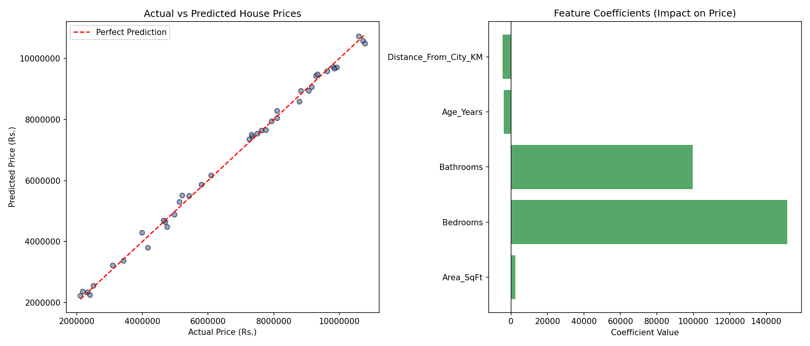

8. Conclusion
This task demonstrates the core supervised machine learning workflow: loading and preparing data, splitting into train/test sets, training a regression model, evaluating it with standard metrics, and interpreting feature coefficients - a foundational skill for predictive modeling tasks.

